GALVANIC COUPLING - EMC OF ELECTRICAL DRIVES ( PART I. )

Irena KOVÁČOVÁ
Department of Electrotechnics, Mechatronics and Industrial Engineering, Technical University of Košice,
Letná 9, 042 00 Košice, Slovak Republic, E-mail: Irena.Kovacova@tuke.sk

Dobroslav KOVÁČ
Department of Theoretical Electrotechnics and Electrical Measurement, Park Komenského 3, 042 00 Košice,
Slovak Republic, Tel: +421-55-60222024; Fax: +421-55-6330115
E-mail: Dobroslav.Kovac@tuke.sk

Abstract This papers deals with the analysis of the electromagnetic compatibility (EMC) – galvanic coupling problems focused to the area of power electrical systems. The description of galvanic coupling problem is divided into two separate parts according the length of common conductors or the working frequency. The first part (PART I.) deals with the galvanic coupling problem of concentrated parameter circuits with short common conductors or with processed signals having low working frequency.

Key words: electromagnetic compatibility, galvanic coupling, common conductors, long lines.

1. Introduction
The problem of galvanic coupling deals with individual electric equipment or their part`s interconnections in such a way, that minimum one or (in some cases as for example feeding net) more common conductors, interconnected these equipments and so mutual influence is generated.

2. Solution for low frequencies and concentrated parameters
The working frequencies and the length of common conductor must be taken always into account. In all cases of the galvanic coupling, the fact that electrical components are not ideal and so they are containing certain parasitic capacitances, inductances and real resistances, is valid. Due to higher working frequency of currents flowed by the common conductors, they must be taken as circuits with distributed parameters, during the process of predictive result galvanic coupling investigation. If the working frequencies will be lower, then the interconnecting circuits can be taken as circuits with concentrated parameters.

2.1. One common conductor - theoretical analysis
Minimum two or more electric circuits, which are mutually galvanically interconnected by one common conductor with its length l, represent a type of galvanic coupling. Due to low frequency operation it is possible to define the common conductor electrical parameters by concentrated parameters of its resistance R and inductance L. If we suppose in the next step, that the conductor will be made of copper, so the voltage drop on its resistance R will be much smaller in comparison with the voltage drop across its inductance L, which is caused by the time depending change of current. So, for the simplified analysis of the problem the conductor resistance will be neglected in the following. The schematic representation of the described problem is shown in the following figure Fig. 1.

Fig. 1. The schematic representation of the circuit interconnections by one common conductor

The mathematical description of the situation in the investigated circuit is then given by the next system of integral-differential equations,

$$u_{1}−u_{L}−u_{2}=u_{1}−L\text{.}\frac{{\text{di}}_{3}}{\text{dt}}−\left(R_{1}\text{.}i_{1}+L_{1}\text{.}\frac{{\text{di}}_{1}}{\text{dt}}+\frac{1}{C_{1}}\text{.}\int{i_{1}\text{.}\text{dt}}\right)=0$$

$$u_{1´}−u_{L}−u_{2´}=u_{1´}−L\text{.}\frac{{\text{di}}_{3}}{\text{dt}}−\left(R_{1´}\text{.}i_{1´}+L_{1´}\text{.}\frac{{\text{di}}_{1´}}{\text{dt}}+\frac{1}{C_{1´}}\text{.}\int{i_{1´}\text{.}\text{dt}}\right)=0$$

$$u_{1^{k}}−u_{L}−u_{2^{k}}=u_{1^{k}}−L\text{.}\frac{{\text{di}}_{3}}{\text{dt}}−\left(R_{1^{k}}\text{.}i_{1^{k}}+L_{1^{k}}\text{.}\frac{{\text{di}}_{1^{k}}}{\text{dt}}+\frac{1}{C_{1^{k}}}\text{.}\int{i_{1^{k}}\text{.}\text{dt}}\right)=0$$

$i_{3}=i_{1}+i_{1´}+\sum_{k=\text{´´}}^{n}{i_{1^{k}}}$ (1)

where (n+2) is number of all different loops, contained in the same common conductor. In the case of great number of loops, the analytic investigation of galvanic coupling influence on individual electric circuits is relatively complicated, so it is possible to utilize the available computer numerical simulation programs.
In the following step, we will try to obtain imagination about the galvanic coupling existence of only two interacting circuits. For the simplification of the analytic investigation it is suitable to suppose, that pure resistors create the loads in both the galvanic connected circuits and that the circuits are in steady states and they are supplied from DC voltage sources as it is shown in figure Fig. 2.

Fig. 2. The investigated circuit

The next equations will be valid for circuit in steady state.

$U_{1}−u_{L}−u_{2}=U_{1}−L\text{.}\frac{{\text{di}}_{3}}{\text{dt}}−R_{1}\text{.}i_{1}=U_{1}−R_{1}\text{.}i_{1}=0$ (2)

$U_{1´}−u_{L}−u_{2´}=U_{1´}−L\text{.}\frac{{\text{di}}_{3}}{\text{dt}}−R_{1´}\text{.}i_{1´}=U_{1´}−R_{1´}\text{.}i_{1´}=0$ (3)

$i_{3}=i_{1}+i_{1´}$ (4)

Let the jump change of supplying voltage from value U_{1´} to zero supposed in lower circuit and no change of supplying voltage or load in the upper circuit. The time dependence description of the voltage u₂ can be obtained by solving the next differential equation system.

$U_{1}−L\text{.}\frac{{\text{di}}_{3}}{\text{dt}}−R_{1}\text{.}i_{1}=0$ (5)

$−L\text{.}\frac{{\text{di}}_{3}}{\text{dt}}−R_{1´}\text{.}i_{1´}=0$ (6)

$i_{3}=i_{1}+i_{1´}$ (7)

By its transformation to the Laplace – Carson’s domain, the next system of linear equations will be created.

$$U_{1}−\text{pL}\text{.}i_{3}(p)+\text{pL}\text{.}i_{3}(0_{−})−R_{1}\text{.}i_{1}(p)=0$$

$−\text{pL}\text{.}i_{3}(p)+\text{pL}\text{.}i_{3}(0_{−})−R_{1´}\text{.}i_{1´}(p)=0$ (8)

$$i_{3}(p)=i_{1}(p)+i_{1´}(p)$$

On the basis of the mentioned system, the equation for current i₃(p) will be derived,

(9)

where i₃(0-) is the current value of inductance L at the moment nearly before the feeding voltage change from value U_{1´} to zero. By back transformation of above mentioned relation to the time domain and after initial condition i₃(0-)= U₁/R₁+ U_{1´}/R_{1´} it is possible to receive the substitution of the following equation.

$i_{3}=\frac{U_{1}}{R_{1}}+\frac{U_{1´}}{R_{1´}}\text{.}e^{−\frac{R_{1}R_{1´}}{L(R_{1}+R_{1´})}\text{.}t}$ (10)

By the expression of load voltage u₂ is possible to investigate the influence of the second circuit to the first activity, caused by the existence of galvanic coupling.

$$u_{2}=U_{1}−u_{L}=U_{1}−L\text{.}\frac{{\text{di}}_{3}}{\text{dt}}=U_{1}+U_{1´}\text{.}\frac{R_{1}}{(R_{1}+R_{1´})}\text{.}e^{−\frac{R_{1}R_{1´}}{L(R_{1}+R_{1´})}\text{.}t}$$
(11)

From the obtained relation it is clear, that the first circuit load voltage is changed about value (U_{1´}.R₁)/(R₁+R_{1´}) due to existence of the change inside the circuit, which is galvanically connected with the previous one. No working activity of the first circuit was done and so its switch on steady state remains. In dependence on load resistor values ratio the voltage drop can be within the open interval (0,U_{1´}).
If the supply voltage switching on state inside the second circuit will be investigated, the information about the voltage load u₂ could be obtained by the similar method.

$$u_{2}=U_{1}−u_{L}=U_{1}−L\text{.}\frac{{\text{di}}_{3}}{\text{dt}}=U_{1}−U_{1´}\text{.}\frac{R_{1}}{(R_{1}+R_{1´})}\text{.}e^{−\frac{R_{1}R_{1´}}{L(R_{1}+R_{1´})}\text{.}t}$$
(12)

It is evident, that the load voltage value inside the first circuit, can be changed about voltage drop within the open interval (-U_{1´},0), again in dependence on load resistor values ratio.
Generally, the switching process inside the second circuit is reflected through galvanic coupling to the total possible load voltage u₂ change within the interval range (-U_{1´}, U_{1´}), depending on load values ratio and sign of derivation of the current flowed via common conductor inductance L.

2.2. One common conductor – simulation and measuring
The computer numerical simulation realized by the PSPICE program helps us to verify the dependencies obtained analytically. Let the common conductor length be is l = 0,1 m. The influence of its magnetic field in distance d = 1 m will be taken into account. The radius of cooper conductors is R = 0,6 mm and its relative permeability is μ_{r} = 0,991.

$\begin{aligned}L=L_{e}+L_{i}=\frac{μ_{0}l}{π}\text{ln}\frac{d−R}{R}+\frac{μ\text{.}l}{8π}= \\ \frac{4π\text{.}{\text{10}}^{−7}\text{.}0,1}{π}\text{ln}\frac{1−0,\text{0006}}{0,\text{0006}}+\frac{0,\text{991}\text{.}4π\text{.}{\text{10}}^{−7}\text{.}0,1}{8π} \\ \text{302} \text{nH}\end{aligned}$ (13)

In the next step will be suppose, that voltage u_{1´} has rectangle shape withthe amplitude 70 V, duty factor z = 0,5 and switching frequency f = 10 kHz. The other circuit parameters are R_{1´} = 11,66 Ω, U₁ = 5 V, R₁ = 10 kΩ and L = 302 nH. Based on the derived equations and given parameters, we can calculate the voltage u₂ peaks so, that the time in the equations (11) and (12) will be replaced by t = 0. Then we can obtain:

$u_{2}(t_{\text{sw} \text{off}})=U_{1}+U_{1´}\text{.}\frac{R_{1}}{(R_{1}+R_{1´})}=5+\text{70}\text{.}\frac{\text{10000}}{\text{10011},\text{66}}=\text{74},\text{918}$ V (14)

Analogically it is possible to state the voltage peak of u₂ at the moment of second circuit switch on.

$u_{2}(t_{\text{sw} \text{on}})=U_{1}−U_{1´}\text{.}\frac{R_{1}}{(R_{1}+R_{1´})}=5−\text{70}\text{.}\frac{\text{10000}}{\text{10011},\text{66}}=−\text{64},\text{918}$ V (15)

The courses of the input voltages u₁ and u_{1´}, the load voltages u₂ and u_{2´} and voltage u_{L} are introduced in figure Fig. 3.

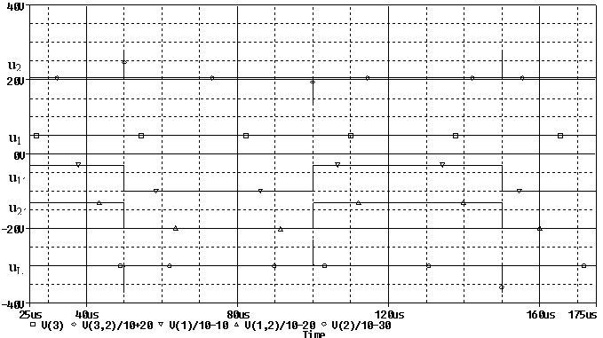

Fig. 3. The results obtained by simulation in the PSPICE program

All data were obtained by computer circuit simulation in the PSPICE program for given circuit parameters. The coincidence of the results obtained analytically as equations derived in the previous parts and by computer numerical simulation is evident, at the first sight. From the courses reached by both methods it is evident, that the galvanic coupling influence between individual investigated electrical circuits is respectable and that in the case of a real converter circuits or their parts can cause serious problems with the total system functionality or eventually the damage of their overvoltage sensitive electronic circuits.
Let the derived results verification will be done by simulation and practical measuring of the power semiconductor converter circuit connected according to the scheme shown in figure Fig. 4.The circuit parameters are: U_{CC} = 70 V, R_{Z} = 11,66 Ω, L_{Z} = 400 μH, L = 302 nH, R = 10 kΩ, U_{BB} = 5 V. The power IGBT transistor is switching with the frequency of 10 kHz and duty cycle z = 0,5.

Fig. 4. The connection of simulated and measured circuit

The courses of transistor voltage u_{CE}, inductance voltage u_{L} and resistance R voltage u_{R} obtained by simulation for the frequency f = 10 kHz are depicted in figure Fig. 5. In this case the voltage jump does

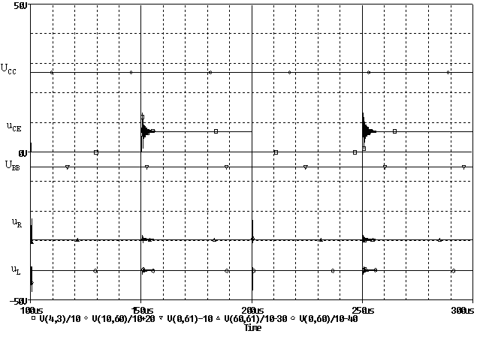

Fig. 5. The results obtained by simulation in the PSPICE program

not exist, because the transistor is switching by a finite velocity. On the basis of this fact, the switching inductance voltage drop reaching the values approximately ±10 V in dependence on the current`s rising or falling slope. The most expressive inductance voltage drop appearing at the moment of the transistor current falling, caused by the existence of the charge of commutation diode. This time, the current slope is markedly increasing, and so the parasitic inductance voltage drop is increasing too. Comparable results, obtained by the verification measurement, are displayed in figure Fig. 6. The coincidence with the simulation results is evident.

Fig. 6. The results obtained by measurement

2.3. Two common conductors - theoretical analysis
The multiple interconnection of electrical or electronics circuits realized by two common conductors is typical especially for one phase or DC feeding conductors, so as it is shown in figure Fig. 7.

Fig. 7. The basic scheme of two conductors circuit interconnection

Due to both the incoming conductor inductance L existence, the total circuit inductance is double. The mutual galvanic coupling is generated at the moment of the optional loop`s impedance change. The impedance can be changed up, or down. This situation is typical for impulse converter circuits, but it is clear that such case occurrs also in all other circuits, which use the switching parts. Circuits, the scheme of which is shown in figure Fig. 8, will serve for the investigation of the effect of such switching

Fig. 8. The investigated circuit

on the rest of the circuits. Let the load voltage be investigated closer at the moment of parallel to resistor R₂ connected circuit`s switching on and then switching off. By the Laplace – Carson transformation, it is possible to write the equation for the investigated loop:

$U_{1}−2\text{pL}\text{.}i(p)+2\text{pL}\text{.}i(0_{−})−R_{1}\text{.}i(p)=0$ (16)

For the current inside the loop, is valid relation:

(17)

By back transformation into time domain, it is possible to obtain expression:

$i=\frac{U_{1}}{\left(R_{1}+R_{2}\right)}\text{.}e^{−\frac{R_{1}}{2L}\text{.}t}+\frac{U_{1}}{R_{1}}\text{.}\left(1−e^{−\frac{R_{1}}{2L}\text{.}t}\right)$ (18)

For load voltage u_{Z} at the moment of circuit closer switching on it is valid:

$u_{z}=R_{1}\text{.}i=U_{1}\text{.}\frac{R_{1}}{\left(R_{1}+R_{2}\right)}\text{.}e^{−\frac{R_{1}}{2L}\text{.}t}+U_{1}\text{.}\left(1−e^{−\frac{R_{1}}{2L}\text{.}t}\right)$ (19)

Analogically, the relation for load voltage u_{Z} at the moment of circuit closer switching off can be derived:

$u_{z}=\left(R_{1}+R_{2}\right)\text{.}i=U_{1}\text{.}\frac{\left(R_{1}+R_{2}\right)}{R_{1}}\text{.}e^{−\frac{\left(R_{1}+R_{2}\right)}{2L}\text{.}t}+U_{1}\text{.}\left(1−e^{−\frac{\left(R_{1}+R_{2}\right)}{2L}\text{.}t}\right)$ (20)

On the basis of the obtained relations, it is possible to find out, that the overvoltage size caused by other electrical circuit activity, can reach also very important values in dependence on individual circuit impedances ratio.

2.4. Two common conductors – simulation

and measuring

The obtained knowledge correctness verification can be done by simulation in the PSPICE program for following circuit parameters U₁ = 70 V, R₁ = 11,66 Ω, R₂ = 100 Ω, L = 302 nH, f = 10 kHz and duty cycle of switching z = 0,5.
By given parameters and equations derived in the previous part, it is possible to calculate the voltage u_{z} peaks so, that in the last equations describing voltage u_{z} the time will be substituted by t = 0.

$u_{z}(t_{\text{sw} \text{on}})=U_{1}\text{.}\frac{R_{1}}{\left(R_{1}+R_{2}\right)}+U_{1}\text{.}\left(1−1\right)=\text{70}\text{.}\frac{\text{11},\text{66}}{\text{11},\text{66}+\text{100}}=7,\text{309}$ V (21)

Analogically, the amplitude of voltage u_{Z} peak at the moment of circuit closer switching off can be derived.

$u_{z}(t_{\text{sw} \text{off}})=U_{1}\text{.}\frac{\left(R_{1}+R_{2}\right)}{R_{1}}\text{.}1+U_{1}\text{.}\left(1−1\right)=\text{70}\text{.}\frac{\left(\text{11},\text{66}+\text{100}\right)}{\text{11},\text{66}}=\text{670},\text{343}$ V (22)

The results obtained by simulation and corresponding measurements are pictured in figures Fig. 9 and Fig. 10.

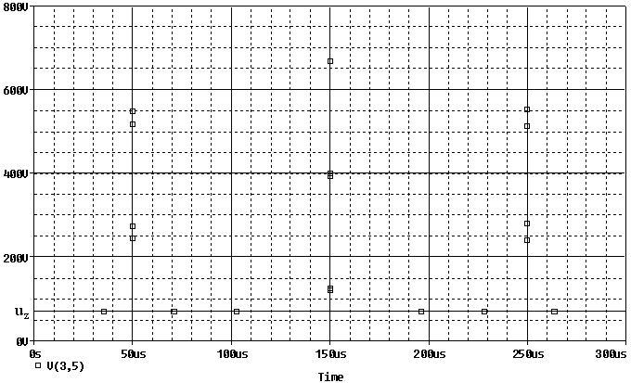

Fig. 9. The results obtained by simulation in the PSPICE program

Fig. 10. The results obtained by measurement

By comparing courses, it is possible to find out, that in all tree cases, the same result was reached. It means, that the derived equations are correct, and can be used for the predictive stating of galvanic coupling influence.

2.5. Several common conductors - theoretical analysis
The interconnecting of many electrical or electronics circuits, by several common conductors, is typical for three phase feeding net, as it is shown in figure Fig. 11. In case, where four conductors will do those circuits interconnection and also if one of them is neutral wire, the problem will be the same as problem of three individual circuits, connected together by only one common conductor. This problem was already analyzed in the first part of this paper.

Fig. 11. The basic scheme of galvanic interconnection, of more circuits by several common conductors

The investigation of three-phase (three conductors) galvanic coupling influence can be done by the analysis of the circuit displayed in figure Fig. 12. The scheme represents a three- phase AC feeding system with long feed conductors, which supplis time variable resistive load. Resistive load is chosen due to the request for the worst possible problem analyze. During the analysis, the symmetrical load will be supposed and also the condition, that all three snappers will be turned on and turned off at the same time.

Fig. 12. The analyzed circuit
Let the steady state with the turn off switchers will be considered according circuit pictured in figure Fig. 12. Now, all switchers will be turned on at certain moment. The circuit can be described by the next system of equations.

$$u_{\text{12}}=L\text{.}\frac{{\text{di}}_{1}}{\text{dt}}+R_{1}\text{.}i_{1}−R_{1}\text{.}i_{2}−L\text{.}\frac{{\text{di}}_{2}}{\text{dt}}$$

$u_{\text{23}}=L\text{.}\frac{{\text{di}}_{2}}{\text{dt}}+R_{1}\text{.}i_{2}−R_{1}\text{.}i_{3}−L\text{.}\frac{{\text{di}}_{3}}{\text{dt}}$ (23)

$$i_{1}+i_{2}+i_{3}=0$$

After its repeated transformation the system of linear equations can be obtained.

$$\begin{aligned}{\overset{}{U}}_{\text{12}}\text{.}\frac{p}{p−jω}={\text{pLi}}_{1}(p)−{\text{pLi}}_{1}(0−)+R_{1}\text{.}i_{1}(p)− \\ −R_{1}\text{.}i_{2}(p)−{\text{pLi}}_{2}(p)+{\text{pLi}}_{2}(0−)\end{aligned}$$

$i_{1}(p)+i_{2}(p)+i_{3}(p)=0$ (24)

By the expressing currents i₂(p) and i₁(p) and by their substitution inside the first equation, one can receive relation for current i₃(p).

(25)

The rest currents i₂(p) and i₁(p) can be calculated by the next substituting.

(26)

(27)

Now, it is possible to do the individual load voltages stating on the base of calculated currents.

(28)
(29)
(30)

After a back transformation to time domain, the system will be given as:

(31)

(32)

(33)

For the general voltage expression, the calculation of initial current conditions must be done at the moment shortly before the turn on of snappers. They can be calculated from the next system of equations.

${\overset{}{U}}_{\text{12}}=jωL\overset{}{I_{1}}+(R_{1}+R_{2})\text{.}\overset{}{I_{1}}−(R_{1}+R_{2})\text{.}\overset{}{I_{2}}−jωL\overset{}{I_{2}}$ (34)

${\overset{}{U}}_{\text{23}}=jωL\overset{}{I_{2}}+(R_{1}+R_{2})\text{.}\overset{}{I_{2}}−(R_{1}+R_{2})\text{.}\overset{}{I_{3}}−jωL\overset{}{I_{3}}$ (35)

$\overset{}{I_{1}}+\overset{}{I_{2}}+\overset{}{I_{3}}=0$ (36)

After solving the previous system the following relations will be obtained:

$\overset{}{I_{1}}=\frac{2{\overset{}{U}}_{\text{12}}+{\overset{}{U}}_{\text{23}}}{3((R_{1}+R_{2})+jωL)}$ (37)

$\overset{}{I_{2}}=\frac{{\overset{}{U}}_{\text{23}}−{\overset{}{U}}_{\text{12}}}{3((R_{1}+R_{2})+jωL)}$ (38)

$\overset{}{I_{3}}=\frac{−2{\overset{}{U}}_{\text{23}}−{\overset{}{U}}_{\text{12}}}{3((R_{1}+R_{2})+jωL)}$ (39)

For individual current differences, expressed by a complex phasor, will be valid that:

$\overset{}{I_{1}}−\overset{}{I_{2}}=\frac{{\overset{}{U}}_{\text{12}}}{(R_{1}+R_{2})+jωL}$ (40)

$\overset{}{I_{2}}−\overset{}{I_{3}}=\frac{{\overset{}{U}}_{\text{23}}}{(R_{1}+R_{2})+jωL}$ (41)

$\overset{}{I_{3}}−\overset{}{I_{1}}=\frac{{\overset{}{U}}_{\text{31}}}{(R_{1}+R_{2})+jωL}$ (42)

The resulting relations for load voltages, expressed by rotating complex phasors, then will have the following form,

${\overset{}{U}}_{Z\text{12}}(jωt)=U_{\text{12}}\text{.}e^{{jϕ}_{U}}\text{.}(\frac{R_{1}}{e^{{jϕ}_{Z1}}\text{.}\sqrt{(R_{1})^{2}+(ωL)^{2}}}(e^{jωt}−e^{−\frac{R_{1}}{L}t})+e^{−\frac{R_{1}}{L}t}\text{.}\frac{R_{1}}{e^{{jϕ}_{Z2}}\text{.}\sqrt{(R_{1}+R_{2})^{2}+(ωL)^{2}}})$ (43)

${\overset{}{U}}_{Z\text{23}}(jωt)=U_{\text{23}}\text{.}e^{{jϕ}_{U}−{\text{120}}^{∘}}\text{.}(\frac{R_{1}}{e^{{jϕ}_{Z1}}\text{.}\sqrt{(R_{1})^{2}+(ωL)^{2}}}(e^{jωt}−e^{−\frac{R_{1}}{L}t})+e^{−\frac{R_{1}}{L}t}\text{.}\frac{R_{1}}{e^{{jϕ}_{Z2}}\text{.}\sqrt{(R_{1}+R_{2})^{2}+(ωL)^{2}}})$ (44)

${\overset{}{U}}_{Z\text{31}}(jωt)=U_{\text{31}}\text{.}e^{{jϕ}_{U}+{\text{120}}^{∘}}\text{.}(\frac{R_{1}}{e^{{jϕ}_{Z1}}\text{.}\sqrt{(R_{1})^{2}+(ωL)^{2}}}(e^{jωt}−e^{−\frac{R_{1}}{L}t})+e^{−\frac{R_{1}}{L}t}\text{.}\frac{R_{1}}{e^{{jϕ}_{Z2}}\text{.}\sqrt{(R_{1}+R_{2})^{2}+(ωL)^{2}}})$ (45)

where

$ϕ_{Z1}=\text{arctg}\frac{ωL}{R_{1}}$ (46)

$ϕ_{Z2}=\text{arctg}\frac{ωL}{R_{1}+R_{2}}$ (47)

$ϕ_{U}=\frac{\text{360}°\text{.}ω\text{.}t(0)}{2π}$ (48)

On the basis of performed analysis, it is evident, that if the resistive load represented by resistors R₂ will have bigger value in comparison with load resistor R₁ values, so the bigger will be also the load voltages fall at the moment of snappers turn on t(0). In extreme cases, the load voltages can be approaching to the value 0 V during the very short time, which depends on the circuit time constant.
Analogically to previous method, the relations for load voltages at the moment of turn off of snappers can be derived.

(49)

(50)

(51)

From the obtained equations, is possible to deduce, that if the resistor R₂ values are much bigger than resistor R₁ values, the largeness of load voltages will be much bigger in comparison with the instantaneous value of nominal feeding voltage.

2.6. Several common conductors – simulation and measuring
The derived equations correctness will be verified in the following PSPICE program simulation. The investigated circuit parameters are U₁₂ = U₂₃ = U₃₁ = 400 V, R₁ = 10 Ω, R₂ = 100 Ω, ϕ_{U} = 90° + ϕ_{Z1}, L = 800 nH, f = 50 Hz. At the moment of snappers turn on, the voltage u₁₂ value will be given as:

${\overset{}{U}}_{Z\text{12}}(jωt(0))=U_{\text{12}}\text{.}e^{{jϕ}_{U}}\text{.}\frac{R_{1}}{e^{{jϕ}_{Z2}}\text{.}\sqrt{(R_{1}+R_{2})^{2}+(ωL)^{2}}}$ (52)

$\begin{aligned}u_{Z\text{12}}=\text{400}\text{.}\sqrt{2}\text{.}\text{sin}({\text{90}}^{∘}+0,{\text{00144}}^{∘}−0,{\text{000131}}^{∘})\text{.} \\ \text{.}\frac{\text{10}}{\sqrt{\text{12100}+\text{63}\text{.}{\text{10}}^{−9}}}=\text{51},\text{42} V\end{aligned}$ (53)

The voltage u₁₂ value at the moment of snappers turn off will be:

${\overset{}{U}}_{Z\text{12}}(jωt(0))=U_{\text{12}}\text{.}e^{{jϕ}_{U}}\text{.}\frac{(R_{1}+R_{2})}{e^{{jϕ}_{Z1}}\text{.}\sqrt{(R_{1})^{2}+(ωL)^{2}}})$ (54)

$u_{Z\text{12}}=\text{400}\text{.}\sqrt{2}\text{.}\text{sin}({\text{90}}^{∘})\text{.}\frac{\text{110}}{\sqrt{\text{100}+\text{63}\text{.}{\text{10}}^{−9}}}=\text{6222},\text{52} V$ (55)

The comparable courses obtained by simulation in the PSPICE program, are shown in following figure Fig. 13. By the analytical and simulation voltage value comparion at the moments of snappers turn on and turn off, it is possible find out, that that their results are identical. Based on above-mentioned, results the fact that the derived equations are valid, and so they can be used by electrical equipment constructers, for the creation of construction vision, concerning the galvanic coupling influence caused by three-phase (three conductors) feeding net.
The results of practical verification measuring, which are confirm the correctness of theoretical results, are displayed in figure Fig. 14.

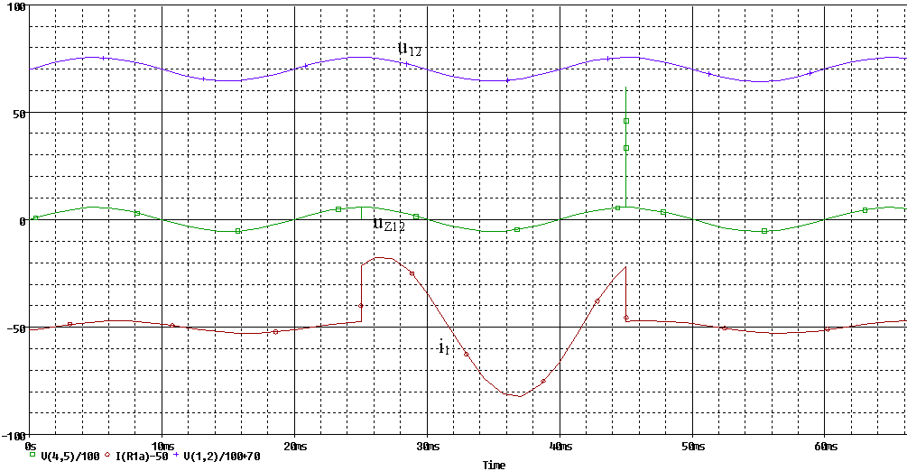

Fig. 13. The courses obtained by simulation

Fig. 14. The results obtained by circuit measuring

3. Conclusion
All performed analyzes indicate, that the derived equations are correct and can be utilized for predictive stating of galvanic coupling influence. Based on above-mentioned, the fact that use derived equations are valid results the conclusion, that they can be utilized by electrical equipment constructers for the creation of construction vision, which is concerns galvanic coupling influence.

Acknowledgement
The paper has been prepared under the support of Slovak grant project No. 1/1084/2004.

References
1. Kaňuch, J.: Investigation methodology design of EMC for drives with disc motor. Dissertation thesis, FEI TU Košice, 2005.
2. Kováčová, I. - Kováč, D.: Parasitic Capacitances of Converters and EMC. Transactions of the Universities of Košice, 2005, No.1, pp.40-47
3. Kováč, K., Lenková, A.: Electromagnetic Compatibility. Bratislava 1999.
4. Carpenter, D. J.: EMC Emissions Certification for Large Systems – A Risk – Management Approach. BT Technology Journal, Springer Science + Bussines Media B. V. Vol 21, 2003, No. 2, pp. 67-76.
5. Electromagnetic Compatibility. Schaffner Elektronik GmbH, Germany 1997.
6. Kováč, D., Kováčová, I.: Influence of Utilizing Static Power Semiconductor Converters on Quality of Electrical Power Line Parameters. Quality Innovation Prosperity, No.1, 2001, pp. 74-84.
7. Gallová, Š.: Tools to Model Uncertainty in Knowledge-based System. Transactions of the Universities of Košice, No. 2, 2001, pp. 1 - 4.
8. Šimko, V., Kováč, D., Kováčová, I.: Bacic circuits I. Elfa s.r.o. Publisher, 2000, 168 Pages, ISBN 80-89066-27-5.
7. Mayer, D., Ulrych, B., Škopek, M.: Electromagnetic Field Analysis by Modern Software Products. Journal of Eletrical Engineering, Vol. 7, No.1, 2001.
8. Göksu, H., Wunsh, D. C: Neural Networks Applied to Electromagnetic Compatibility Simulations. Lecture Notes in Computer Science, Springer - Verlag GmbH, Vol. 2714, 2003, pp. 1057-1063.
9. Rybár, R., Kudelas, D., Fischer, G.: Alternative sources of energy III – Winding energy. Textbook, Košice, 2004.
10. Kováčová, I., Kaňuch, J., Kováč, D.: DC permanent magnet disc motor design with improved EMC. Acta Technica CSAV, Vol. 50, No.3, 2005, pp.291-306.
11. Ruddle, A. R., Parmantier, J. P., Ferrieres, X., Ward, D. D.: Experimental Varidation of Time – Domain Electromagnetic Models for Field Coupling Into the Interior of a Vehicle from a Nearby Broadband Anntena. Proceedings of IEE International Conference on Comunication in Electromagnetic CEM 2004, Stratford- Upon-Avon, 2004, pp. 133-134.
12. Gallová, Š.: A Progressive Manufacturing Operation. International Congress MATAR, Prague 2004, pp.141 – 146.
13. Kováčová, I.: EMC of Power DC Electrical Drives. Journal of Electrical Engineering, Vol. 5, No. 1, 2005, pp.61-66.
14. Kováčová, I. - Kaňuch, J. - Kováč, D.: EMC Power Electrotechnic Systems. Eqilibria Publisher, s.r.o., Košice, 2005, 182 pages, ISBN 80-969224-5-9.
15. Kováčová, I., Kováč, D.: EMC Compatibility of Power Semiconductor Converters and Inverters. Acta Electrotechnica et Informatica, No.2, Vol. 3, 2003, pp. 12-14.
16. Gallová, Š.: Numerical Control Programming Approach. Transactions of the Universities of Košice, No. 1, 2004, pp. 48-52.
17. Kováčová, I., Kováč, D.: Safeguard Circuits of Power Semiconductor Parts. Acta Electrotechnica et Informatica, No.3, Vol. 3, 2003, pp. 44-45.
18. Kůs, V.: The influence of power semiconductor converters on power distribution net, BEN – technical literature Publisher, Praha 2002, 184 pages, ISBN 80-7300-062-8.

